Trainer’s Manual

Adaptive Physical Activity (APA) Program for Chronic Stroke
Table of Contents

Section 1………………………………...Criteria for exercises Role of the APA instructor

Section 2………………………………………………………..……..Motivational guides

Section 3…………………………………………………………...APA Profile (example)

Section 4…………………………………………………..Class check-in sheet (example)

Section 5………………………………………………….........Exercise progression guide

Section 6……………………………………………………………..Exercise explanations

Section 7………………………………Home exercise chart and exercise explanations

Note: This manual is intended to provide a program overview and technical support to instructors of APA stroke courses. This should be used in conjunction with training from APA program (research) staff. Separate materials will be provided for the individual participants for daily check-in and home exercise books.

Section 1

Criteria for exercises
and
Role of the APA instructor

CRITERIA FOR THE APPLICATION OF THE EXERCISES
1. Walking represents the warm up phase before the exercise begins. The duration of the warm up progressively increases from 6 – 9 – 12 min. and reaches 12 min. during the third week of work. A large space is required to guarantee safety, therefore there should not be any unwanted obstacles; supports should be present along the path itself (bars on the wall, chairs, etc)
2. The walking is intended to stimulate improvement of the patient’s balance and upper-lower limb coordination during movement.
3. The proposed workout MUST NOT be more difficult than what has been estimated in the plan and it may be necessary to adapt the proposed pace to each subjects’ ability.
4. The exercises must always be performed with “double safety precautions”: immediate precautions to prevent accidents or discomforts during the lesson, secondary precautions to avoid physical or psychological consequences emerging after the class (soreness, fatigue, etc).
5. The exercises must always be accompanied by a functional explanation tailored to the individual patient in order to reveal the significance of seemingly inconsequential movements. The tasks must be compelling and engaging in order to stimulate an active and involved motor coordination response.

ROLE OF THE APA INSTRUCTOR
The instructor is in charge of managing the entire exercise activity and carrying out each lesson.
His/her role is complex because it includes both the function of a professionally qualified and “competent technician” and the function of an enthusiastic and charged motivator, able to engage the subject in the exercises even when the individual does not feel properly able. The provider must look after the single individual and the group, he/she also must empathize with and pay attention to the feedback of the participants. It is best to enunciate and speak loudly using simple but accurate terminology. It is necessary to explain the goal of each of the exercises so the participants understand the logic behind them.
APA Home Exercise Program

Home exercises are performed during the days off from the center activities.

Instructors must:
-Clearly explain to the patient the task he/she is requested to accomplish
-Underline the importance of at home exercise and walking
-Explain the importance of recording the activities daily
-Check the journal weekly and discuss barriers with each client weekly
-Emphasize to the patient the importance of answering honestly!

Section 2

Motivational guides
Weekly phone check-in phone script:
How have you been doing with your exercise homework? Have you been keeping up with it? Let’s review what you’ve done in the last week.
How much walking have you been able to do every day? (Review daily walk times in patient exercise log)

Goal Met: That’s GREAT! Congratulations on meeting the goal! Doesn’t it feel great to be making progress?! Don’t you feel good about doing this on a regular basis?! You know, getting some kind of exercise every day is a very important part of your recovery. I want to help you get better and do it safely; that’s the reason we developed the worksheets that you’re doing such a great job of following!! Keep it up!

Goal Not Met: Hmmm…that’s not exactly what we’d hoped you’d be able to do. What kind of problems are you having that keep you from doing the walking? (Record on Flowsheet). I’d like to help you get back on track and continue your walking for exercise on the days you’re not here. How can I help you do that? Great-thanks for helping me understand what’s getting in the way of your progress. I want to help you get better and doing some form of exercise every day is a very important part of getting better.

How about the other exercises? How’re they going? (Review log)

Goal Met: That’s GREAT! Congratulations on keeping up with it!! You know, getting some kind of exercise every day is a very important part of your recovery. I want to help you get better and do it safely; that’s the reason we developed the exercises for you to do at home!! Keep it up!

Goal Not Met: Hmmm…that’s not exactly what we’d hoped you’d be able to do. What kind of problems are you having that keep you from doing the exercises? (Record on Flowsheet). I’d like to help you figure out a way to do these exercises at home. What is getting in the way of that? Great-thanks for helping me understand what’s getting in the way of your progress. I want to help you get better and doing some form of exercise every day is a very important part of getting better.

Are you having any problems? Anything at all that I can help you with?
Please feel free to call me at ____________________ if you need help with this program. I know it’s a big change for you, and I really want to see you succeed!
We’ll chat again next week to review your exercise progress and log book, so keep up the good work-and keep track of it!

Exercises for Recovery Following your stroke:

EXERCISE WILL...
- Help you become physically fit by improving your:
  - Muscle strength
  - Muscle endurance (the ability of the muscle to keep repeating an activity without getting tired)

BENEFITS OF EXERCISE
- Help you become physically fit by improving your:
  - Flexibility (the ability to move your joints-arms, legs, neck and back)
  - Balance (the ability to maintain your body upright)

A Balanced Fitness Program Includes:
- Aerobic exercises-walking
- Resistive exercises-weight training with hand held weights or rubberbands
- Flexibility training-muscle stretching

To be beneficial the Exercise program must:
- Involve the use of large muscle groups in a prolonged, rhythmic manner for at least 15 minutes, at least 3 days a week at moderate or greater intensity.

Exercise Intensity
- Mild intensity is maintaining a heart rate that is 60% of the maximum for age (220-age x .60)….walking at a comfortable speed. Maximum mild intensity for me is _____
- Moderate intensity is maintaining a heart rate that is 60 to 80% of the maximum for age (220-Age x .80)….walking at a quick pace.
- Moderate intensity for me is ______

INCREASE YOUR EXERCISE BY…..
- Beginning a regular organized program of exercise.

EXERCISE SHOULD BE…...
- Structured so that you set up a regular time to exercise…..and get yourself to stick to that schedule
Realistic….don’t set goals that you can’t meet!
- SAFE…..warning signs of excessive exercise include:
  - severe shortness of breath, wheezing, coughing, chest pain, excessive perspiration, dizziness, fatigue for more than 1/2 hour after exercise.
- CONVENIENT…..
  - Expensive or specialized equipment and facilities that you can’t get to won’t help you stick to an exercise program. Home exercise is cheap and easy.

- ENJOYABLE….
  - LISTEN TO MUSIC
  - WEAR AN EXERCISE SUIT
  - GET A BUDDY!
  - MAKE IT FUN!
  - REWARD YOURSELF!

OVERCOME THE BARRIERS TO EXERCISE
- THERE IS NO PLACE TO EXERCISE….
  - YOU CAN EXERCISE RIGHT AT HOME FOLLOWING THE EXERCISE PROGRAM GIVEN TO YOU AND A SET DAILY SCHEDULE.
I AM TOO OLD TO EXERCISE
    - *EXERCISE HAS IMPORTANT BENEFITS AT ANY AGE*
    - IT’S BEEN DEMONSTRATED THAT JUST INCREASING WALKING ALONE IMPROVES FITNESS IN STROKE SURVIVORS
- THE WEATHER IS OFTEN A PROBLEM……
  - Your exercise program can be done at home….indoors.
- FEEL TOO TIRED TO EXERCISE????????
    - The exercise will give you energy….try it and see!
- Too much pain to exercise…..
  - Pain medication and other treatments can help control pain to get you started….and exercise can help prevent future pain.
- Don’t have the time to exercise?
  - It is less than an hour a day.
  - Set a regular exercise time and stick to it!
- Worried about getting hurt????
  - The exercises given to you are ones that you can do safely. Exercise will strengthen your bones and muscles and is the best way to prevent a fall.
- WORRIED ABOUT FAILING?
  - You will not fail….these are exercises YOU CAN DO!

Section 3

APA Profile (example)
APA PROFILE

Name: DOB:

Emergency Contact and Phone: MD Name and Phone:

Allergies:

Medical History:

Medications:

Exercise Limitations:

Section 4

Class check-in sheet (example)
WEEK 1
DATE | Falls or ‘near falls’? | Barriers to home exercise? | Feeling well today? | Take your meds today? | HR & BP
 |  |  |  |  | HR
 |  |  |  |  | BP /
 |  |  |  |  | HR
 |  |  |  |  | BP /
 |  |  |  |  | HR
 |  |  |  |  | BP /

WEEK 2
DATE | Falls or ‘near falls’? | Barriers to home exercise? | Feeling well today? | Take your meds today? | HR & BP
 |  |  |  |  | HR
 |  |  |  |  | BP /
 |  |  |  |  | HR
 |  |  |  |  | BP /
 |  |  |  |  | HR
 |  |  |  |  | BP /

WEEK 3
DATE | Falls or ‘near falls’? | Barriers to home exercise? | Feeling well today? | Take your meds today? | HR & BP
 |  |  |  |  | HR
 |  |  |  |  | BP /
 |  |  |  |  | HR
 |  |  |  |  | BP /
 |  |  |  |  | HR
 |  |  |  |  | BP /

WEEK 4
DATE | Falls or ‘near falls’? | Barriers to home exercise? | Feeling well today? | Take your meds today? | HR & BP
 |  |  |  |  | HR
 |  |  |  |  | BP /
 |  |  |  |  | HR
 |  |  |  |  | BP /
 |  |  |  |  | HR
 |  |  |  |  | BP /

WEEK 5
DATE | Falls or ‘near falls’? | Barriers to home exercise? | Feeling well today? | Take your meds today? | HR & BP
 |  |  |  |  | HR
 |  |  |  |  | BP /
 |  |  |  |  | HR
 |  |  |  |  | BP /
 |  |  |  |  | HR
 |  |  |  |  | BP /

WEEK 6
DATE | Falls or ‘near falls’? | Barriers to home exercise? | Feeling well today? | Take your meds today? | HR & BP
 |  |  |  |  | HR
 |  |  |  |  | BP /
 |  |  |  |  | HR
 |  |  |  |  | BP /
 |  |  |  |  | HR
 |  |  |  |  | BP /

WEEK 7
DATE | Falls or ‘near falls’? | Barriers to home exercise? | Feeling well today? | Take your meds today? | HR & BP
 |  |  |  |  | HR
 |  |  |  |  | BP /
 |  |  |  |  | HR
 |  |  |  |  | BP /
 |  |  |  |  | HR
 |  |  |  |  | BP /

WEEK 8
DATE | Falls or ‘near falls’? | Barriers to home exercise? | Feeling well today? | Take your meds today? | HR & BP
 |  |  |  |  | HR
 |  |  |  |  | BP /
 |  |  |  |  | HR
 |  |  |  |  | BP /
 |  |  |  |  | HR
 |  |  |  |  | BP /

WEEK 9
DATE | Falls or ‘near falls’? | Barriers to home exercise? | Feeling well today? | Take your meds today? | HR & BP
 |  |  |  |  | HR
 |  |  |  |  | BP /
 |  |  |  |  | HR
 |  |  |  |  | BP /
 |  |  |  |  | HR
 |  |  |  |  | BP /

WEEK 10
DATE | Falls or ‘near falls’? | Barriers to home exercise? | Feeling well today? | Take your meds today? | HR & BP
 |  |  |  |  | HR
 |  |  |  |  | BP /
 |  |  |  |  | HR
 |  |  |  |  | BP /
 |  |  |  |  | HR
 |  |  |  |  | BP /

WEEK 11
DATE | Falls or ‘near falls’? | Barriers to home exercise? | Feeling well today? | Take your meds today? | HR & BP
 |  |  |  |  | HR
 |  |  |  |  | BP /
 |  |  |  |  | HR
 |  |  |  |  | BP /
 |  |  |  |  | HR
 |  |  |  |  | BP /

WEEK 12
DATE | Falls or ‘near falls’? | Barriers to home exercise? | Feeling well today? | Take your meds today? | HR & BP
 |  |  |  |  | HR
 |  |  |  |  | BP /
 |  |  |  |  | HR
 |  |  |  |  | BP /
 |  |  |  |  | HR
 |  |  |  |  | BP /

WEEK 13
DATE | Falls or ‘near falls’? | Barriers to home exercise? | Feeling well today? | Take your meds today? | HR & BP
 |  |  |  |  | HR
 |  |  |  |  | BP /
 |  |  |  |  | HR
 |  |  |  |  | BP /
 |  |  |  |  | HR
 |  |  |  |  | BP /

WEEK 14
DATE | Falls or ‘near falls’? | Barriers to home exercise? | Feeling well today? | Take your meds today? | HR & BP
 |  |  |  |  | HR
 |  |  |  |  | BP /
 |  |  |  |  | HR
 |  |  |  |  | BP /
 |  |  |  |  | HR
 |  |  |  |  | BP /

WEEK 15
DATE | Falls or ‘near falls’? | Barriers to home exercise? | Feeling well today? | Take your meds today? | HR & BP
 |  |  |  |  | HR
 |  |  |  |  | BP /
 |  |  |  |  | HR
 |  |  |  |  | BP /
 |  |  |  |  | HR
 |  |  |  |  | BP /

WEEK 16
DATE | Falls or ‘near falls’? | Barriers to home exercise? | Feeling well today? | Take your meds today? | HR & BP
 |  |  |  |  | HR
 |  |  |  |  | BP /
 |  |  |  |  | HR
 |  |  |  |  | BP /
 |  |  |  |  | HR
 |  |  |  |  | BP /

WEEK 17
DATE | Falls or ‘near falls’? | Barriers to home exercise? | Feeling well today? | Take your meds today? | HR & BP
 |  |  |  |  | HR
 |  |  |  |  | BP /
 |  |  |  |  | HR
 |  |  |  |  | BP /
 |  |  |  |  | HR
 |  |  |  |  | BP /

WEEK 18
DATE | Falls or ‘near falls’? | Barriers to home exercise? | Feeling well today? | Take your meds today? | HR & BP
 |  |  |  |  | HR
 |  |  |  |  | BP /
 |  |  |  |  | HR
 |  |  |  |  | BP /
 |  |  |  |  | HR
 |  |  |  |  | BP /

WEEK 19
DATE | Falls or ‘near falls’? | Barriers to home exercise? | Feeling well today? | Take your meds today? | HR & BP
 |  |  |  |  | HR
 |  |  |  |  | BP /
 |  |  |  |  | HR
 |  |  |  |  | BP /
 |  |  |  |  | HR
 |  |  |  |  | BP /

WEEK 20
DATE | Falls or ‘near falls’? | Barriers to home exercise? | Feeling well today? | Take your meds today? | HR & BP
 |  |  |  |  | HR
 |  |  |  |  | BP /
 |  |  |  |  | HR
 |  |  |  |  | BP /
 |  |  |  |  | HR
 |  |  |  |  | BP /

WEEK 21
DATE | Falls or ‘near falls’? | Barriers to home exercise? | Feeling well today? | Take your meds today? | HR & BP
 |  |  |  |  | HR
 |  |  |  |  | BP /
 |  |  |  |  | HR
 |  |  |  |  | BP /
 |  |  |  |  | HR
 |  |  |  |  | BP /

WEEK 22
DATE | Falls or ‘near falls’? | Barriers to home exercise? | Feeling well today? | Take your meds today? | HR & BP
 |  |  |  |  | HR
 |  |  |  |  | BP /
 |  |  |  |  | HR
 |  |  |  |  | BP /
 |  |  |  |  | HR
 |  |  |  |  | BP /

WEEK 23
DATE | Falls or ‘near falls’? | Barriers to home exercise? | Feeling well today? | Take your meds today? | HR & BP
 |  |  |  |  | HR
 |  |  |  |  | BP /
 |  |  |  |  | HR
 |  |  |  |  | BP /
 |  |  |  |  | HR
 |  |  |  |  | BP /

WEEK 24
DATE | Falls or ‘near falls’? | Barriers to home exercise? | Feeling well today? | Take your meds today? | HR & BP
 |  |  |  |  | HR
 |  |  |  |  | BP /
 |  |  |  |  | HR
 |  |  |  |  | BP /
 |  |  |  |  | HR
 |  |  |  |  | BP /

Section 5

Exercise progression guide
Exercise progression by week.
Name of exercise | Month 1 | Week 5 | Week 6 | Week 7 | Week 8 | Week 9 | Week 10 | Week 11 | Week 12 | Week 13 until end
Walking warm up | 6 minutes | 7 minutes | 8 minutes | 9 minutes | 10 minutes | 11 minutes | 12 minutes | 13 minutes | 14 minutes | 15 minutes
Weight shift* | 5 per side | 8 per side |  |  |  | 10 per side
Forward shift* | 5 per side | 8 per side |  |  |  | 10 per side
Side Step* | 5 per side | 8 per side |  |  |  | 10 per side
Backward Step* | 5 per side | 8 per side |  |  |  | 10 per side
Squats* | 5 per side | 8 per side |  |  |  | 10 per side
Backward Leg Raise* | 5 per side | 8 per side |  |  |  | 10 per side
Sideways Leg Raise* | 5 per side | 8 per side |  |  |  | 10 per side
Forward Leg Raise* | 5 per side | 8 per side |  |  |  | 10 per side
Marching* | 5 per side | 8 per side |  |  |  | 10 per side
Arm Rotation* | 5 per side | 8 per side |  |  |  | 10 per side
Trunk Rotation* | 5 per side | 8 per side |  |  |  | 10 per side
Forward Trunk Bend* | 5 per side | 8 per side |  |  |  | 10 per side
Sit to Stand* | 5 per side | 8 per side |  |  |  | 10 per side
Walk/Obstacle Course | 6 minutes | 7 minutes | 8 minutes | 9 minutes | 10 minutes | 11 minutes | 12 minutes | 13 minutes | 14 minutes | 15 minutes
*=perform exercise, rest and repeat

Section 6

Exercise explanations
Walking Warm Up
Walk the perimeter of the room for time as indicated by
Week Number.
Weight Shift:
Stand facing the bar and hold on for balance.
Shift weight to the right and back to center.
Shift weight to the left and back to center.
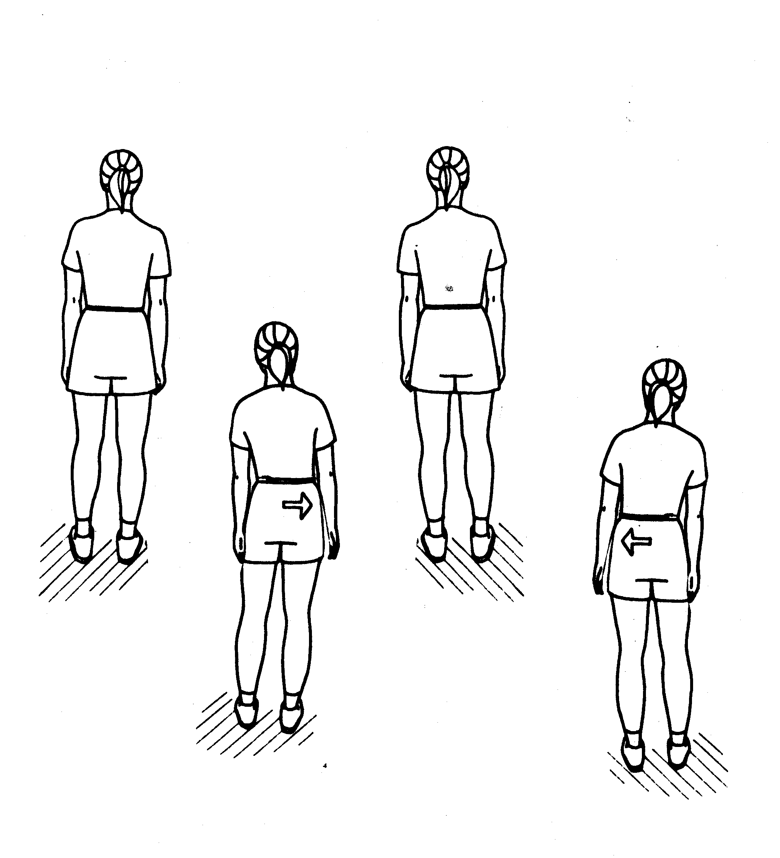
Forward Step:
Stand facing the bar and hold on for balance.
Step right foot forward, shift weight forward, and return foot back.
Step left foot forward, shift weight forward, and return
foot back.
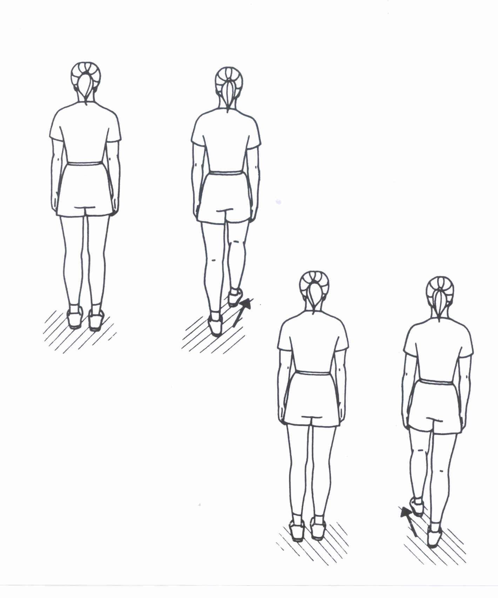

Side Step:
Stand facing the bar and hold on for balance.
Step right foot sideways, shift weight onto right foot,
and return foot back.
Step left foot sideways, shift weight onto left, and
return foot back.
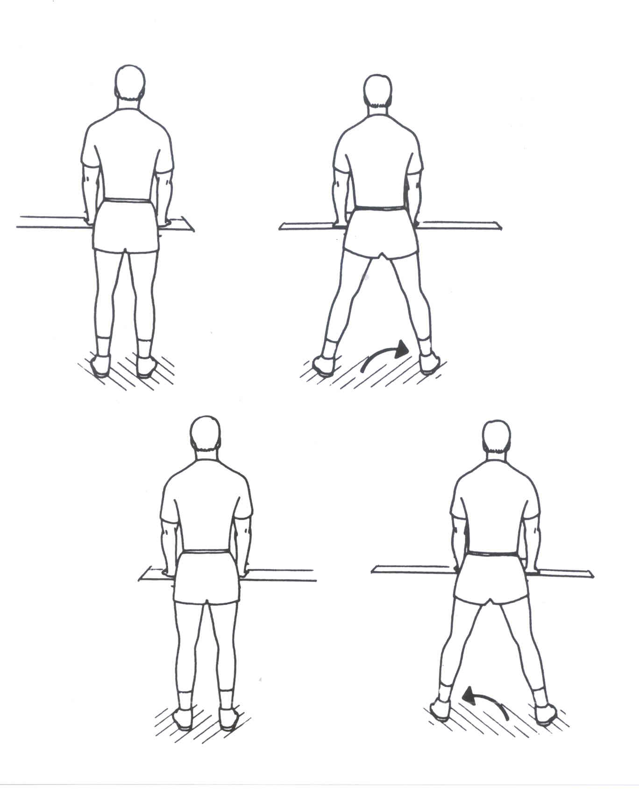
Backward Step:
Stand facing the bar and hold on for balance.
Step right foot backward, shift weight backward, and return foot to starting position.
Step left foot backward, shift weight backward, and return foot to starting position.
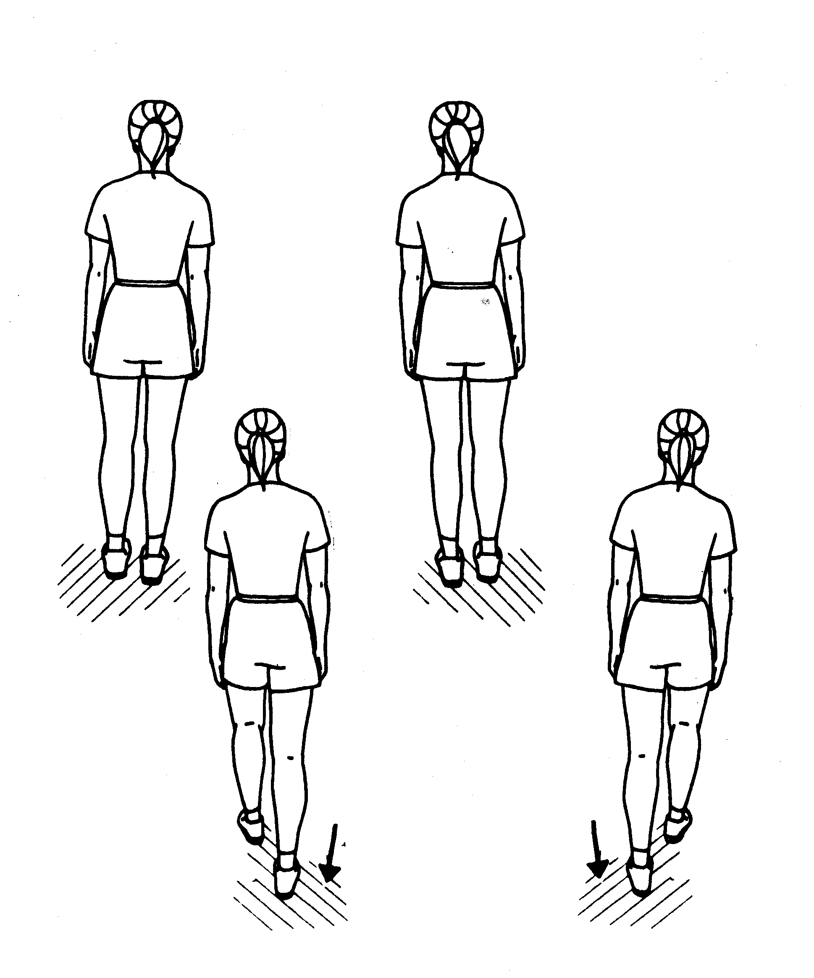

Squats:
Stand facing the bar and hold on for balance.
Bend knees to squat comfortably.
Return to standing.

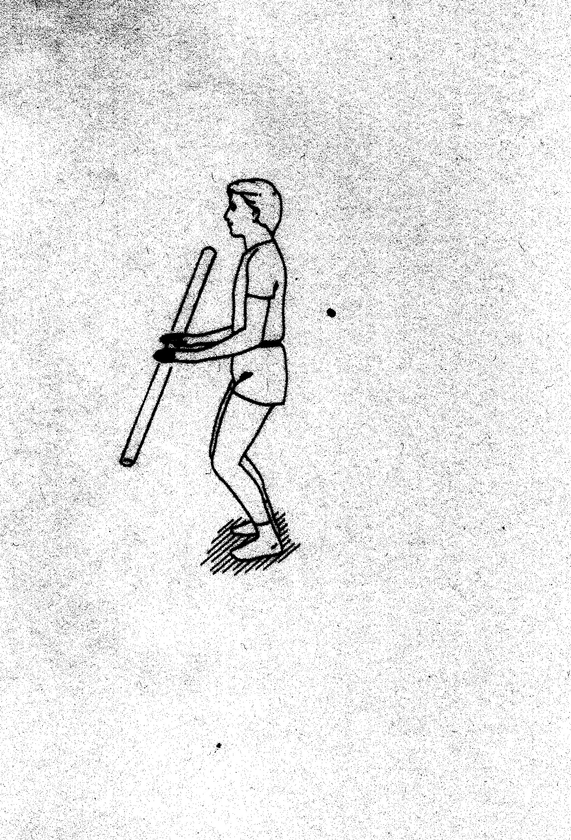

Backward Leg Raise:
Stand facing the bar and hold on for balance.
Raise right leg backward.
Return to starting position.
Repeat with left leg.
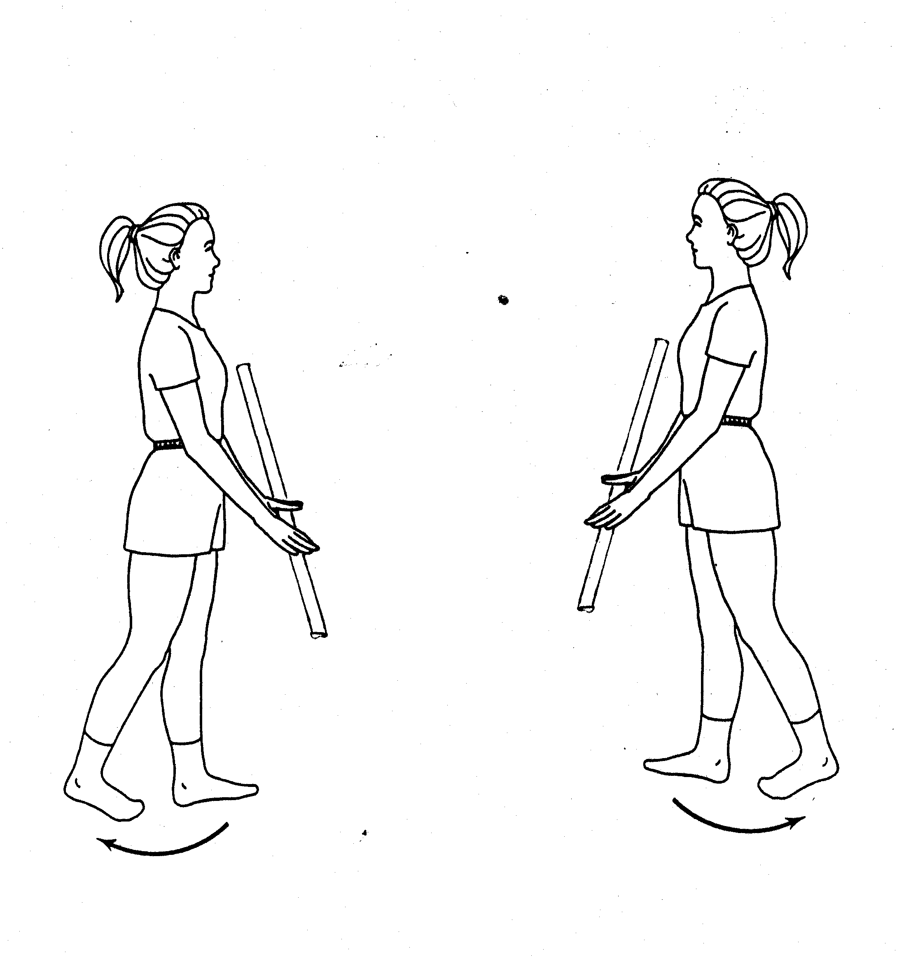

Sideways Leg Raise:
Stand facing the bar and hold on for balance.
Raise right leg up sideways.
Return to starting position.
Repeat with left leg.

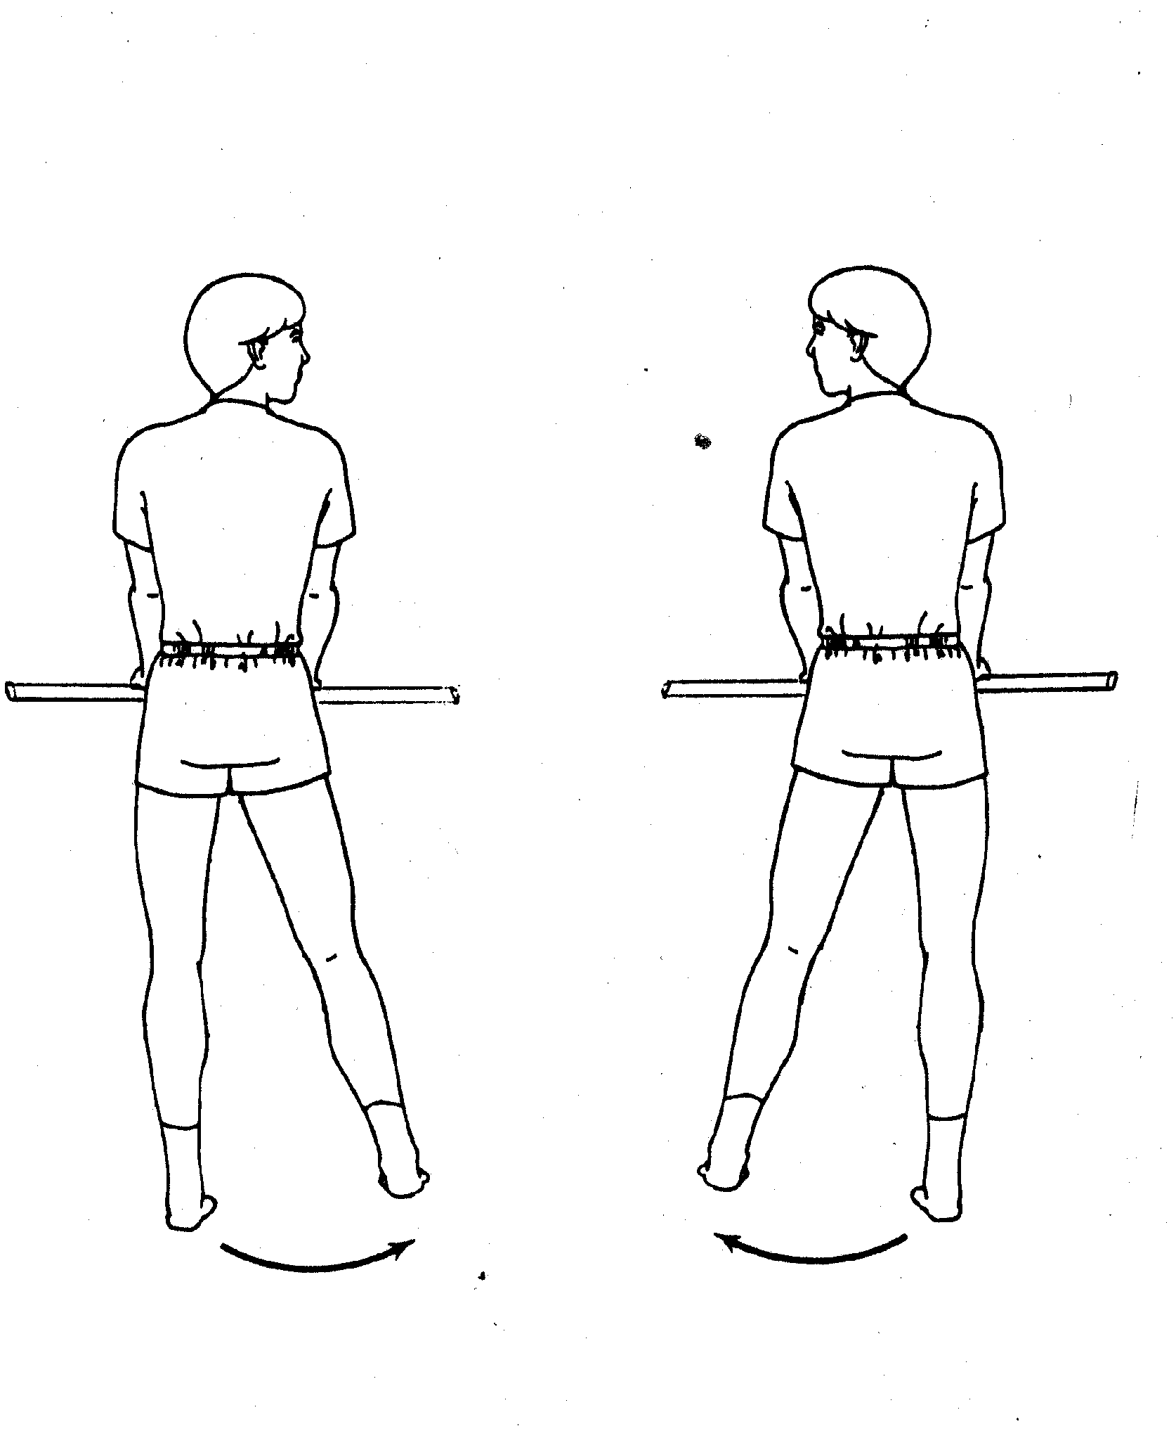

Forward Leg Raise:
Stand sideways to the bar and hold on for balance.
Raise right leg up forward.
Return to starting position.
Repeat with left leg.
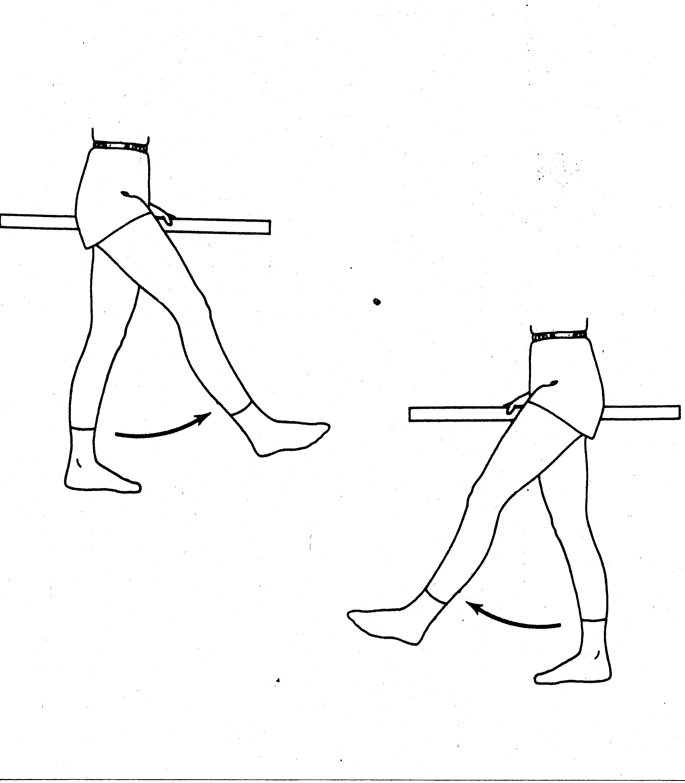

Marching:
Stand facing the bar OR sideways to the bar and hold on for balance.
March in place, alternating the right then the left leg.
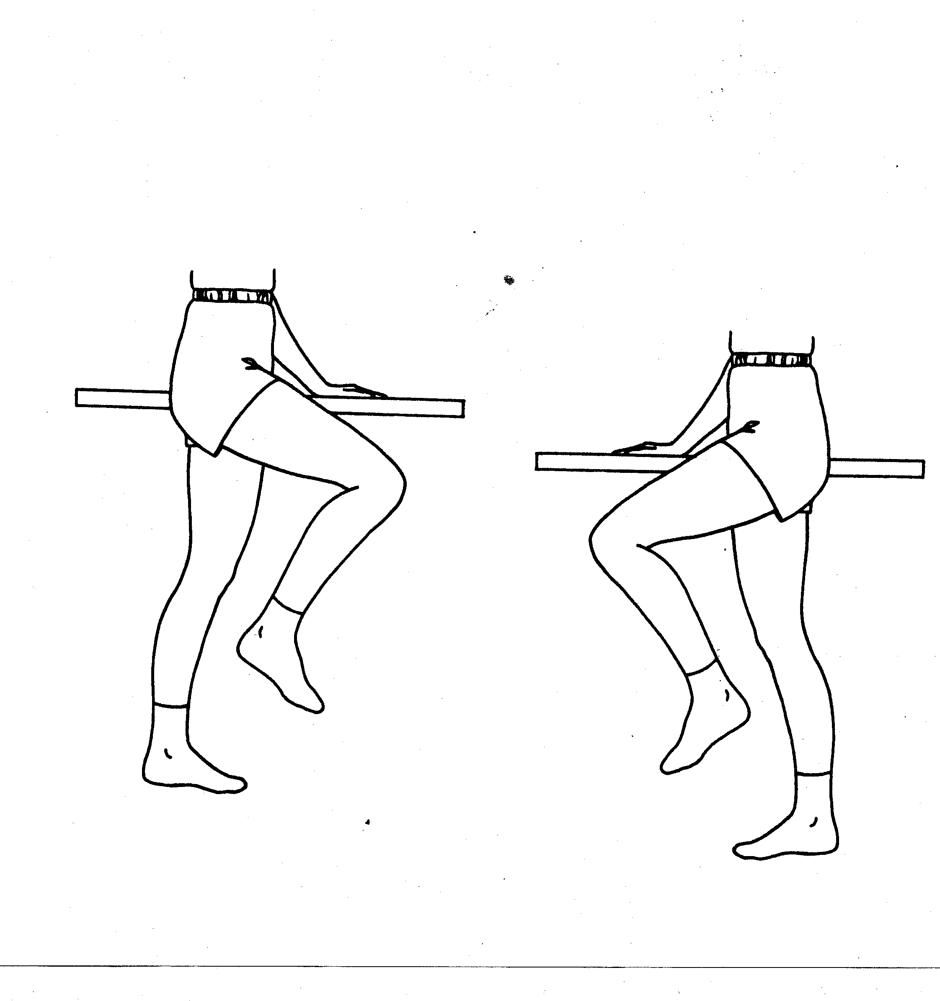

Arm Rotation:
Interlace fingers and raise arms to shoulder level.
Turn hands and arms to the right, then the left
(like a steering wheel).

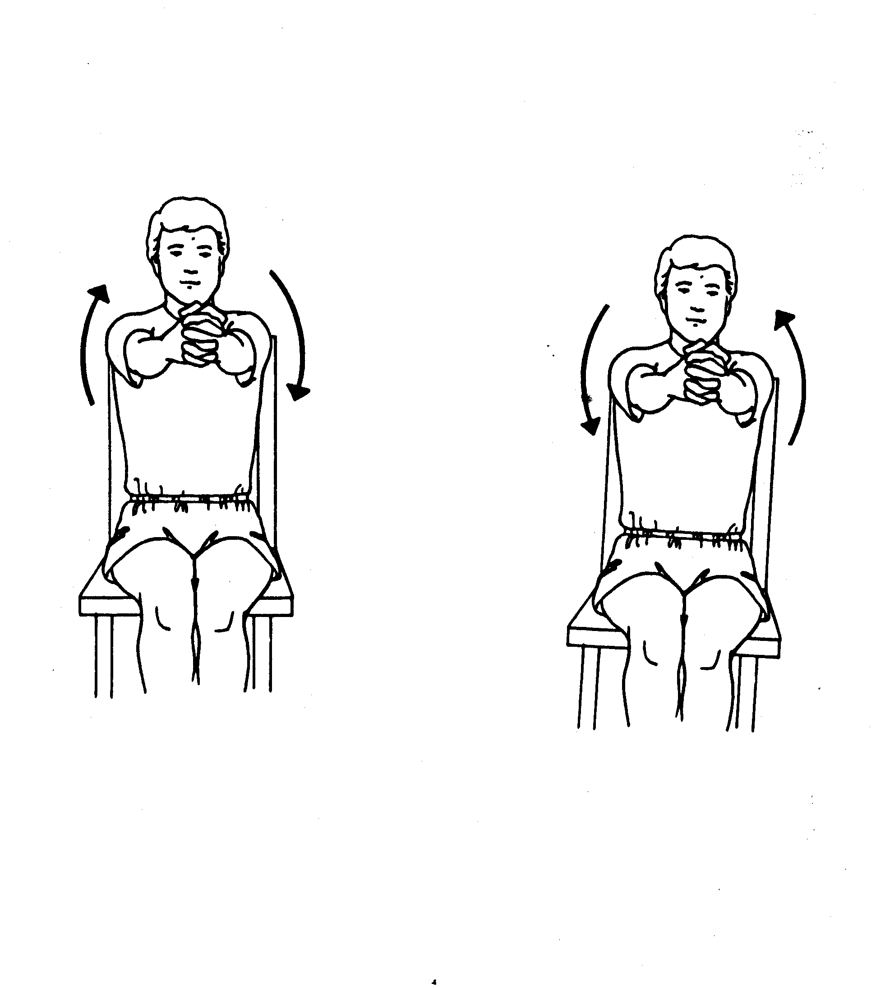
Trunk Rotation 1:
Cross arms over one another. Twist trunk to the right, back to the center, and to the left.

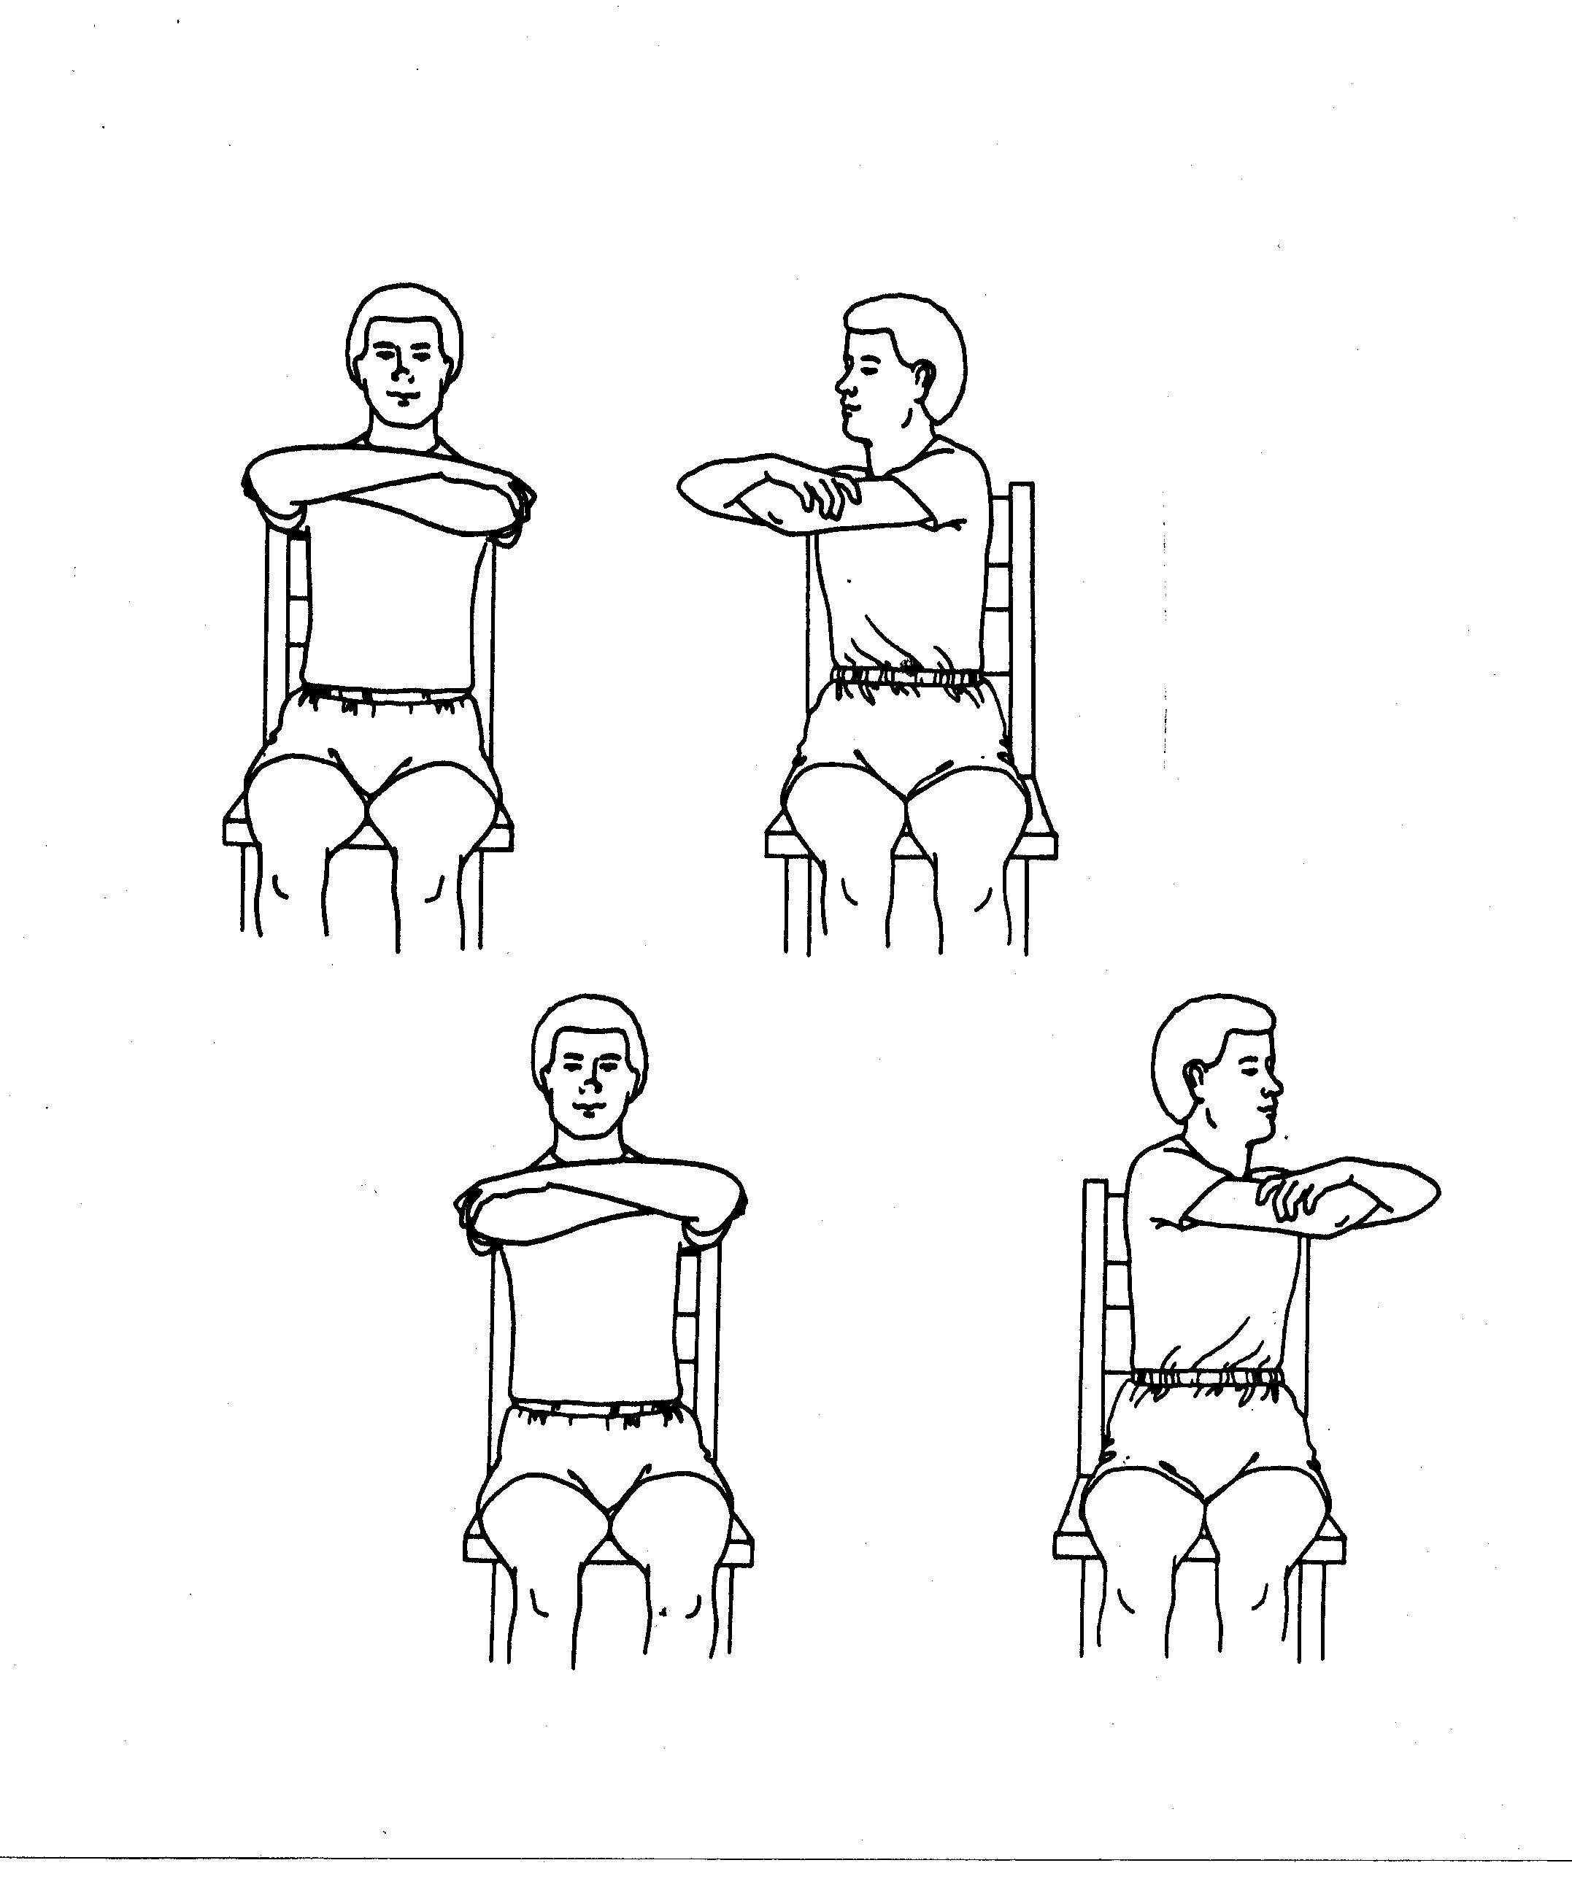

Trunk Rotation 2:
Interlace fingers together and raise arms forward to shoulder level. Twist trunk to the right, back to the center, and to the left.

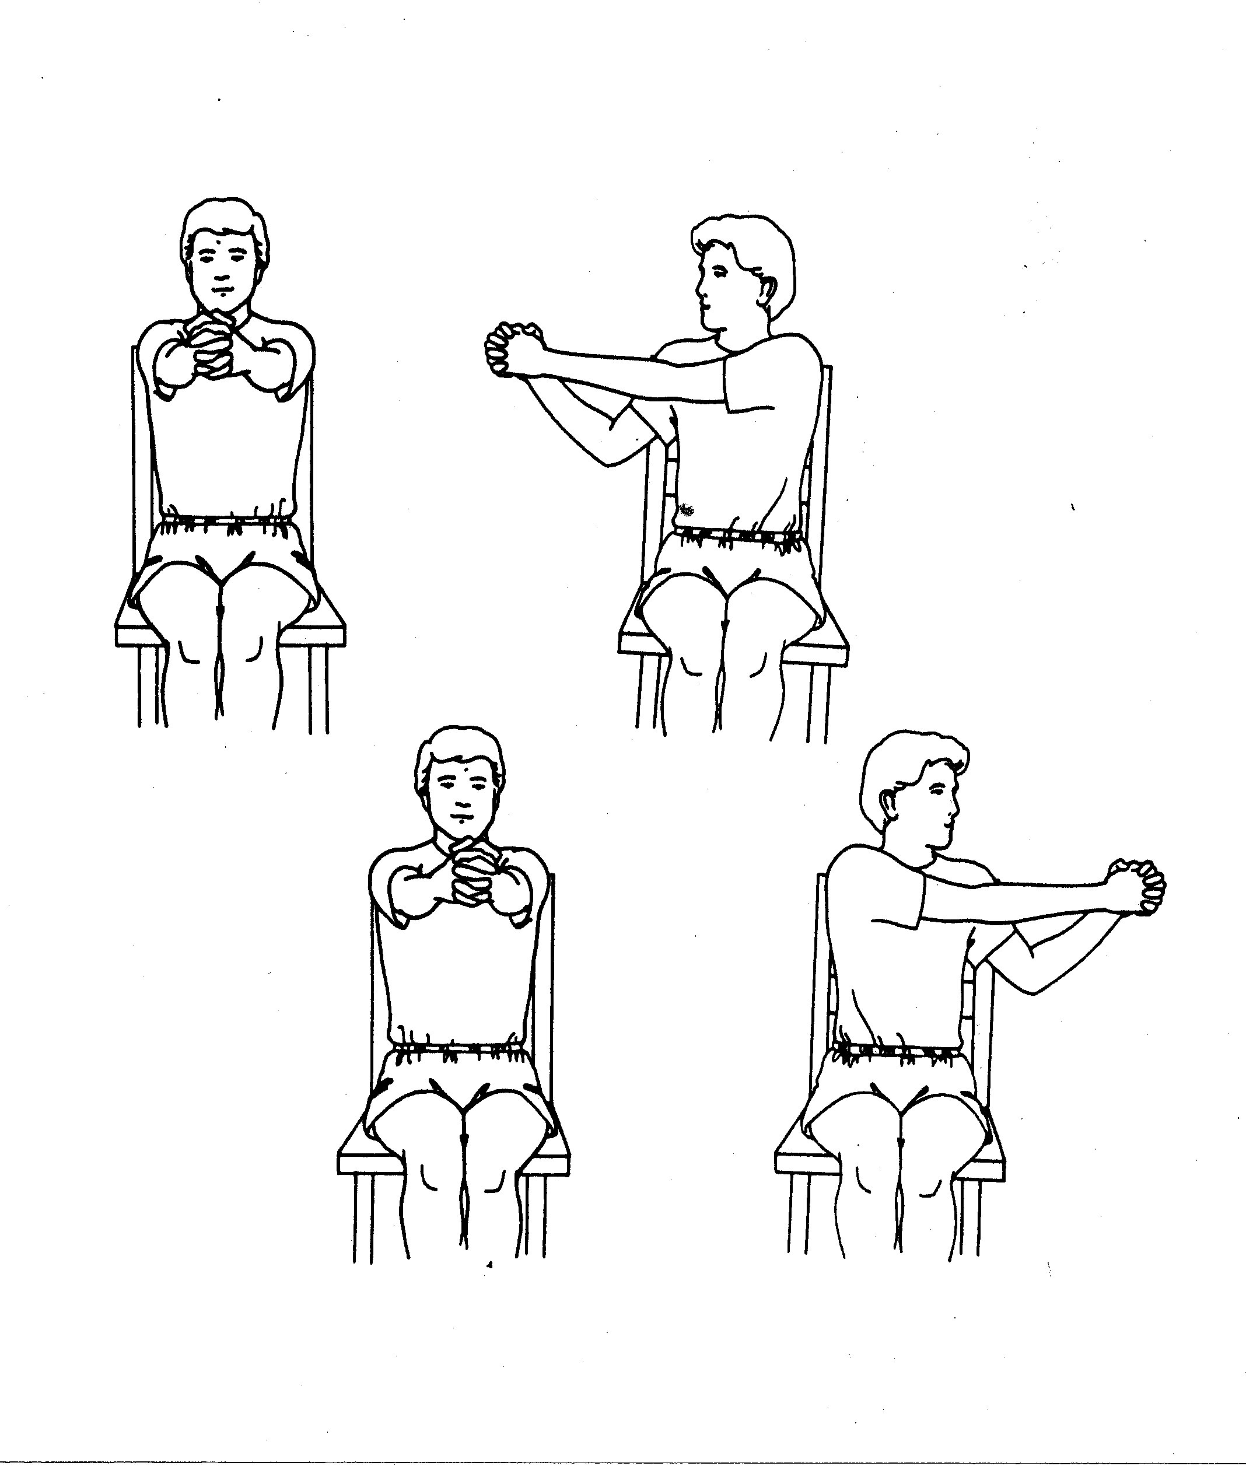

Forward Trunk Bending
Interlace fingers and raise arms forward to shoulder level.
Bend forward carefully and slide hands down the side of the right leg, as close to the floor as you can. Return to the upright position.
Repeat to the left side.
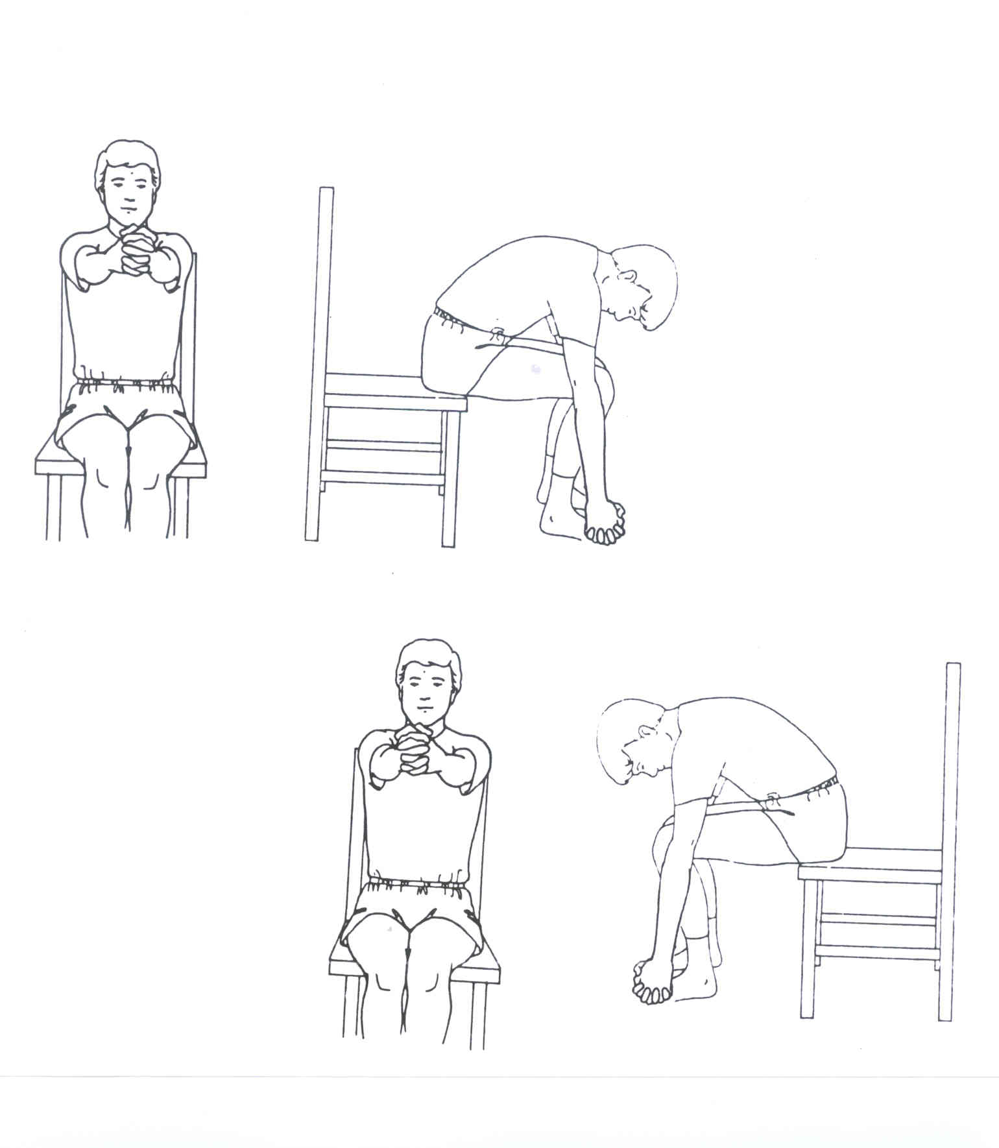

Sit to Stand
Sit up straight on the edge of the chair. Place hands on knees for balance.
Stand up using your leg muscles as much as possible (try to use your hands as little as possible).

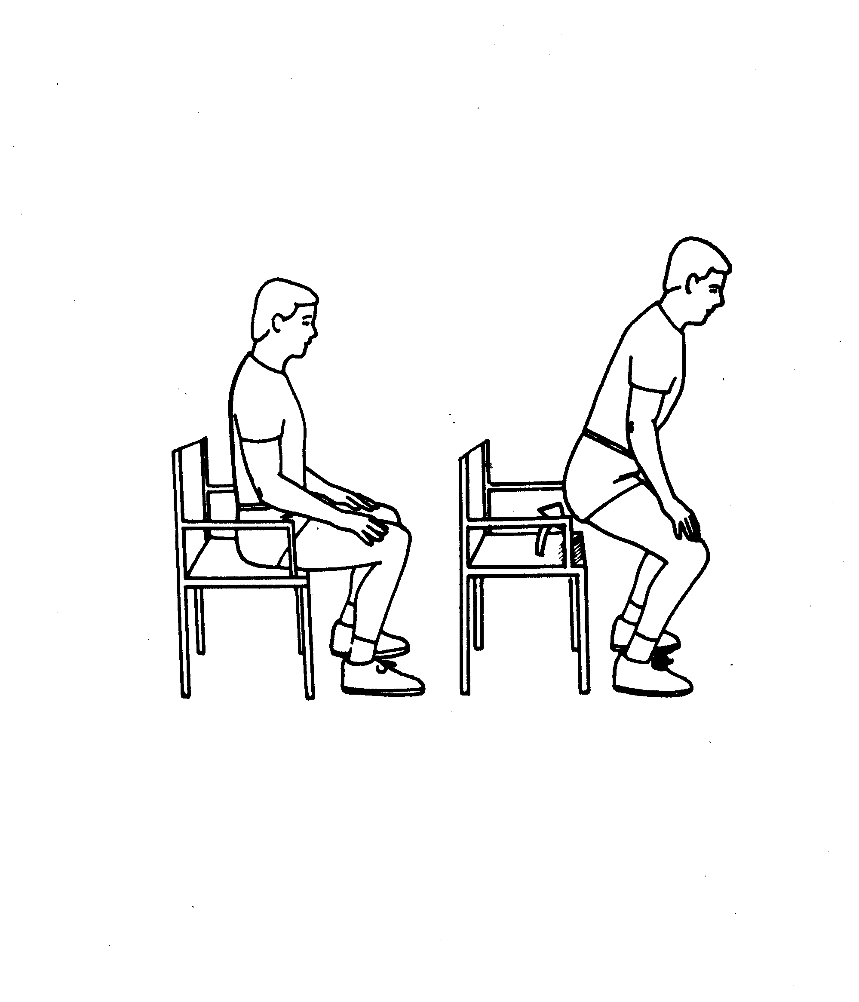

Obstacle Course:
Walk obstacle course for time as indicated by
Week Number.

Section 7

Home exercise chart and exercise
explanations
Home Exercise Checklist.
ACTIVITY |  | Week 1 |  |  | Week 2 |  |  | Week 3 |  |  | Week 4
ACTIVITY |  | TUE | TR | SAT | TUE | TR | SAT | TUE | TR | SAT | TUE | TR | SAT
Walking (continuously if possible) | Goal | 6 minutes |  |  | 6 minutes |  |  | 6 minutes |  |  | 6 minutes
Walking (continuously if possible) | Actual Time
From a chair, stand up and sit back down | Goal | 5 times consecutively |  |  | 5 times consecutively |  |  | 7 times consecutively |  |  | 7 times consecutively
From a chair, stand up and sit back down | Actual
Sitting with fingers laced, raise hands up over head | Goal | 3 repetitions |  |  | 3 repetitions |  |  | 5 repetitions |  |  | 5 repetitions
Sitting with fingers laced, raise hands up over head | Actual
Leg stretch (hamstring stretch) | Goal | Hold for 30 seconds |  |  | Hold for 30 seconds |  |  | Hold for 30 seconds |  |  | Hold for 30 seconds
Leg stretch (hamstring stretch) | Actual
Bridges: raise hips up and hold for 5 seconds | Goal | 3 repetitions |  |  | 3 repetitions |  |  | 5 repetitions |  |  | 5 repetitions
Bridges: raise hips up and hold for 5 seconds | Actual
Lying on back, bend knees and draw heels up toward buttock. Lower knees to one side, then the other | Goal | 10 repetitions |  |  | 10 repetitions |  |  | 15 repetitions |  |  | 15 repetitions
 | Actual

ACTIVITY |  | Week 5 |  |  | Week 6 |  |  | Week 7 |  |  | Week 8
ACTIVITY |  | TUE | TR | SAT | TUE | TR | SAT | TUE | TR | SAT | TUE | TR | SAT
Walking (continuously if possible) | Goal | 6 minutes |  |  | 6 minutes |  |  | 9 minutes |  |  | 9 minutes
Walking (continuously if possible) | Actual
From a chair, stand up and sit back down | Goal | 7 times consecutively |  |  | 9 times consecutively |  |  | 9 times consecutively |  |  | 9 times consecutively
From a chair, stand up and sit back down | Actual
Sitting with fingers laced, raise hands up over head | Goal | 5 repetitions |  |  | 5 repetitions |  |  | 8 repetitions |  |  | 8 repetitions
Sitting with fingers laced, raise hands up over head | Actual
Leg stretch (hamstring stretch) | Goal | Hold for 30 seconds |  |  | Hold for 30 seconds |  |  | Hold for 30 seconds |  |  | Hold for 30 seconds
Leg stretch (hamstring stretch) | Actual
Bridges: raise hips up and hold for 5 seconds | Goal | 5 repetitions |  |  | 5 repetitions |  |  | 8 repetitions |  |  | 8 repetitions
Bridges: raise hips up and hold for 5 seconds | Actual
Lying on back, bend knees and draw heels up toward buttock. Lower knees to one side, then the other | Goal | 15 repetitions |  |  | 20 repetitions |  |  | 20 repetitions |  |  | 20 repetitions
 | Actual

ACTIVITY |  | Week 9 |  |  | Week 10 |  |  | Week 11 |  |  | Week 12
ACTIVITY |  | TUE | TR | SAT | TUE | TR | SAT | TUE | TR | SAT | TUE | TR | SAT
Walking (continuously if possible) | Goal | 9 minutes |  |  | 12 minutes |  |  | 12 minutes |  |  | 12 minutes
Walking (continuously if possible) | Actual
From a chair, stand up and sit back down | Goal | 7 times consecutively |  |  | 9 times consecutively |  |  | 9 times consecutively |  |  | 9 times consecutively
From a chair, stand up and sit back down | Actual
Sitting with fingers laced, raise hands up over head | Goal | 5 repetitions |  |  | 5 repetitions |  |  | 8 repetitions |  |  | 8 repetitions
Sitting with fingers laced, raise hands up over head | Actual
Leg stretch (hamstring stretch) | Goal | Hold for 30 seconds |  |  | Hold for 30 seconds |  |  | Hold for 30 seconds |  |  | Hold for 30 seconds
Leg stretch (hamstring stretch) | Actual
Bridges: raise hips up and hold for 5 seconds | Goal | 5 repetitions |  |  | 5 repetitions |  |  | 8 repetitions |  |  | 8 repetitions
Bridges: raise hips up and hold for 5 seconds | Actual
Lying on back, bend knees and draw heels up toward buttock. Lower knees to one side, then the other | Goal | 15 repetitions |  |  | 20 repetitions |  |  | 20 repetitions |  |  | 20 repetitions
 | Actual

ACTIVITY |  | Week 13 |  |  | Week 14 |  |  | Week 15 |  |  |  | Week 16
ACTIVITY |  | TUE | TR | SAT | TUE | TR | SAT | TUE | TR | SAT |  | TUE | TR | SAT
Walking (continuously if possible) | Goal | 12 minutes |  |  | 12 minutes |  |  | 12 minutes |  |  | 12 minutes
Walking (continuously if possible) | Actual
From a chair, stand up and sit back down | Goal | 7 times consecutively |  |  | 9 times consecutively |  |  | 9 times consecutively |  |  | 9 times consecutively
From a chair, stand up and sit back down | Actual
Sitting with fingers laced, raise hands up over head | Goal | 5 repetitions |  |  | 5 repetitions |  |  | 8 repetitions |  |  | 8 repetitions
Sitting with fingers laced, raise hands up over head | Actual
Leg Stretch (hamstring stretch) | Goal | Hold for 30 seconds |  |  | Hold for 30 seconds |  |  | Hold for 30 seconds |  |  | Hold for 30 seconds
Leg Stretch (hamstring stretch) | Actual
Bridges: raise hips up and hold for 5 seconds | Goal | 5 repetitions |  |  | 5 repetitions |  |  | 8 repetitions |  |  | 8 repetitions
Bridges: raise hips up and hold for 5 seconds | Actual
Lying on back, bend knees and draw heels up toward buttock. Lower knees to one side, then the other | Goal | 15 repetitions |  |  | 20 repetitions |  |  | 20 repetitions |  |  | 20 repetitions
 | Actual

ACTIVITY |  | Week 17 |  |  | Week 18 |  |  | Week 19 |  |  | Week 20
ACTIVITY |  | TUE | TR | SAT | TUE | TR | SAT | TUE | TR | SAT | TUE | TR | SAT
Walking (continuously if possible) | Goal | 9 minutes |  |  | 12 minutes |  |  | 12 minutes |  |  | 12 minutes
Walking (continuously if possible) | Actual
From a chair, stand up and sit back down | Goal | 7 times consecutively |  |  | 9 times consecutively |  |  | 9 times consecutively |  |  | 9 times consecutively
From a chair, stand up and sit back down | Actual
Sitting with fingers laced, raise hands up over head | Goal | 5 repetitions |  |  | 5 repetitions |  |  | 8 repetitions |  |  | 8 repetitions
Sitting with fingers laced, raise hands up over head | Actual
Leg Stretch (hamstring stretch) | Goal | Hold for 30 seconds |  |  | Hold for 30 seconds |  |  | Hold for 30 seconds |  |  | Hold for 30 seconds
Leg Stretch (hamstring stretch) | Actual
Bridges: raise hips up and hold for 5 seconds | Goal | 5 repetitions |  |  | 5 repetitions |  |  | 8 repetitions |  |  | 8 repetitions
Bridges: raise hips up and hold for 5 seconds | Actual
Lying on back, bend knees and draw heels up toward buttock. Lower knees to one side, then the other | Goal | 15 repetitions |  |  | 20 repetitions |  |  | 20 repetitions |  |  | 20 repetitions
 | Actual

ACTIVITY |  | Week 21 |  |  | Week 22 |  |  | Week 23 |  |  | Week 24
ACTIVITY |  | TUE | TR | SAT | TUE | TR | SAT | TUE | TR | SAT | TUE | TR | SAT
Walking (continuously if possible) | Goal | 12 minutes |  |  | 12 minutes |  |  | 12 minutes |  |  | 12 minutes
Walking (continuously if possible) | Actual
From a chair, stand up and sit back down | Goal | 7 times consecutively |  |  | 9 times consecutively |  |  | 9 times consecutively |  |  | 9 times consecutively
From a chair, stand up and sit back down | Actual
Sitting with fingers laced, raise hands up over head | Goal | 5 repetitions |  |  | 5 repetitions |  |  | 8 repetitions |  |  | 8 repetitions
Sitting with fingers laced, raise hands up over head | Actual
Leg Stretch (hamstring stretch) | Goal | Hold for 30 seconds |  |  | Hold for 30 seconds |  |  | Hold for 30 seconds |  |  | Hold for 30 seconds
Leg Stretch (hamstring stretch) | Actual
Bridges: raise hips up and hold for 5 seconds | Goal | 5 repetitions |  |  | 5 repetitions |  |  | 8 repetitions |  |  | 8 repetitions
Bridges: raise hips up and hold for 5 seconds | Actual
Lying on back, bend knees and draw heels up toward buttock. Lower knees to one side, then the other | Goal | 15 repetitions |  |  | 20 repetitions |  |  | 20 repetitions |  |  | 20 repetitions
 | Actual

Forward Arm Raising
Interlace fingers with hands in your lap. Raise hands together up in front of you, as far up as you can go comfortably.

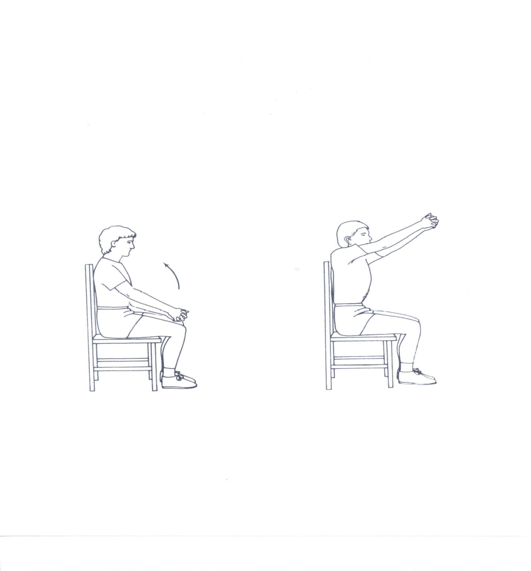

Lower Trunk Rotation Stretch
Lie on your back and bend your knees so your feet are flat on the bed. Gently lower your knees to the right, keeping your shoulders flat on the bed. Raise them back up, and then lower to the left side. You should feel a gentle stretch along the sides of the trunk on both sides.

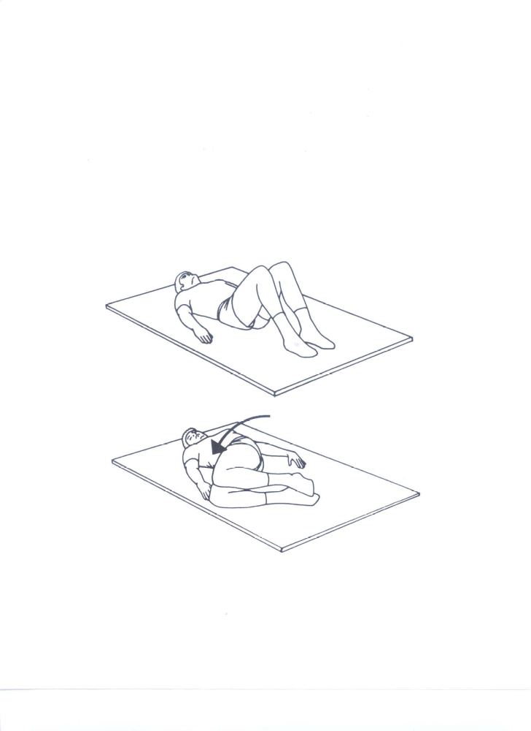
Bridging
Lie on your back and bend your knees so your feet are flat on the bed. Raise your hips up toward the ceiling, then lower them back down.
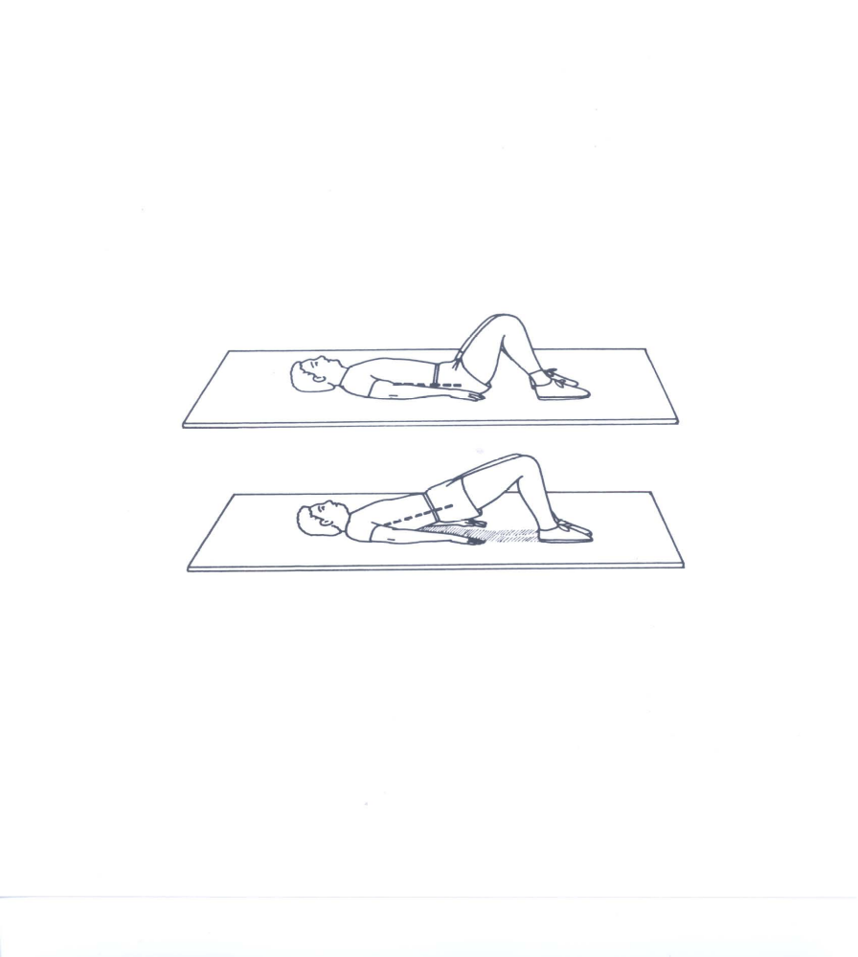
Leg Stretch
Sit with right leg straight. Gently lean forward toward your toes while keeping your back straight. You should feel a gentle stretch in the back of your thigh. Hold the stretch for 30 seconds.
Repeat with the left leg.
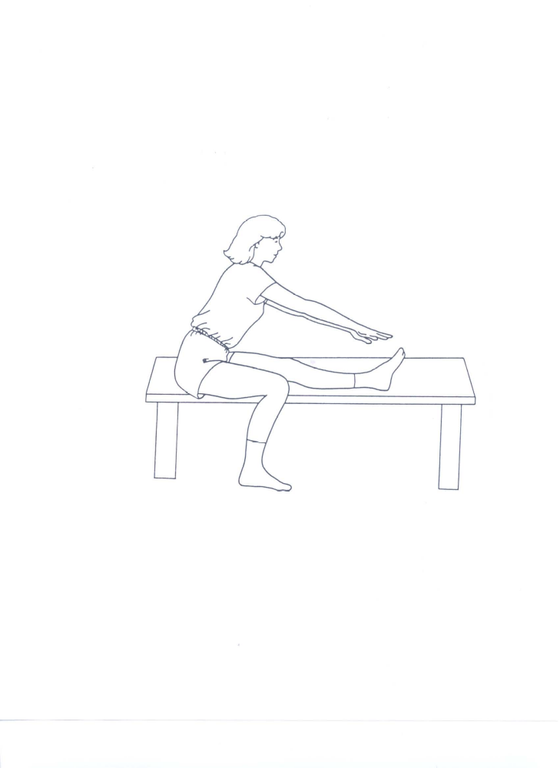
Sit to Stand
Sit up straight on the edge of the chair. Place hands on knees for balance.
Stand up using your leg muscles as much as possible (try to use your hands as little as possible).

